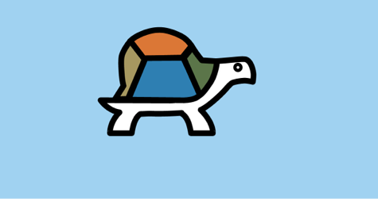

SUGAR LABS

**Sugar Labs**

08

**Fall**

Advanced Blocks Manual for Turtle Blocks

Sugar Labs

Prepared by Emily Ong Hui Qi

Table of Contents

All About Turtle Blocks 3

What is Turtle Blocks? 3

Where can we get Turtle Blocks? 3

Turtle Palette 4

Angle-Arc-Radius Block 4

Bezier Block 5

Set Heading Block 6

Set xy Block 6

Media Palette 7

Show Block 7

Text Tool 7

Video Tool 8

Camera Tool 8

Speak Tool 9

Shell Block 9

Image tool 9

Turtle Shell 10

Sensors 11

Loudness Block 11

Mouse Blocks 11

Keyboard Block 12

Time Block 13

Extras Palette 13

Save SVG Tool 13

# All About Turtle Blocks

## What is Turtle Blocks?

Turtle Blocks is an activity with a Logo-inspired graphical "turtle" that draws colorful art based on snap-together visual programming elements. Its "low floor" provides an easy entry point for beginners. It also has "high ceiling" programming features, which will challenge the more adventurous student.

## Where can we get Turtle Blocks?

<http://activities.sugarlabs.org/en-US/sugar/addon/4027>

**Note:** There are two inter-compatible programs: [Turtle Art](http://activities.sugarlabs.org/en-US/sugar/addon/4298) and [Turtle Blocks](http://activities.sugarlabs.org/en-US/sugar/addon/4027). Turtle Art, which closely parallels the Java version of Turtle Art maintained by Brian Silverman, offers a small subset of the functionality of Turtle Blocks. **Sugar users probably want to use Turtle Blocks rather than Turtle Art.** (Also see [Turtle Confusion](http://wiki.sugarlabs.org/go/Activities/Turtle_Confusion), a collection of programming challenges designed by Barry Newell; as well as the [Activities/TurtleFlags](http://wiki.sugarlabs.org/go/Activities/TurtleFlags), [Activities/Tortuga de Mexico](http://wiki.sugarlabs.org/go/Activities/Tortuga_de_Mexico) and [Activities/Amazonas Tortuga](http://wiki.sugarlabs.org/go/Activities/Amazonas_Tortuga) variants.)

Debian (and Ubuntu) users can install Turtle Blocks from a repository maintained by Alan Aguiar ([https://launchpad.net/~alanjas/+archive/turtleblocks](https://launchpad.net/%7Ealanjas/+archive/turtleblocks)):

1. sudo add-apt-repository ppa:alanjas/turtleblocks
2. sudo apt-get update
3. sudo apt-get install turtleblocks

Fedora users can do:

1. sudo yum install sugar-turtleart

For those of you who would like to use Turtle Blocks in a browser, there is a mostly compatible version at [Turtle Blocks JS](http://turtle.sugarlabs.org). See [the Guide](https://github.com/walterbender/turtleblocksjs/blob/master/guide/README.md) ([en ES](https://github.com/walterbender/turtleblocksjs/blob/master/guide-es/README.md)) for more details.

# Turtle Palette

## Angle-Arc-Radius Block

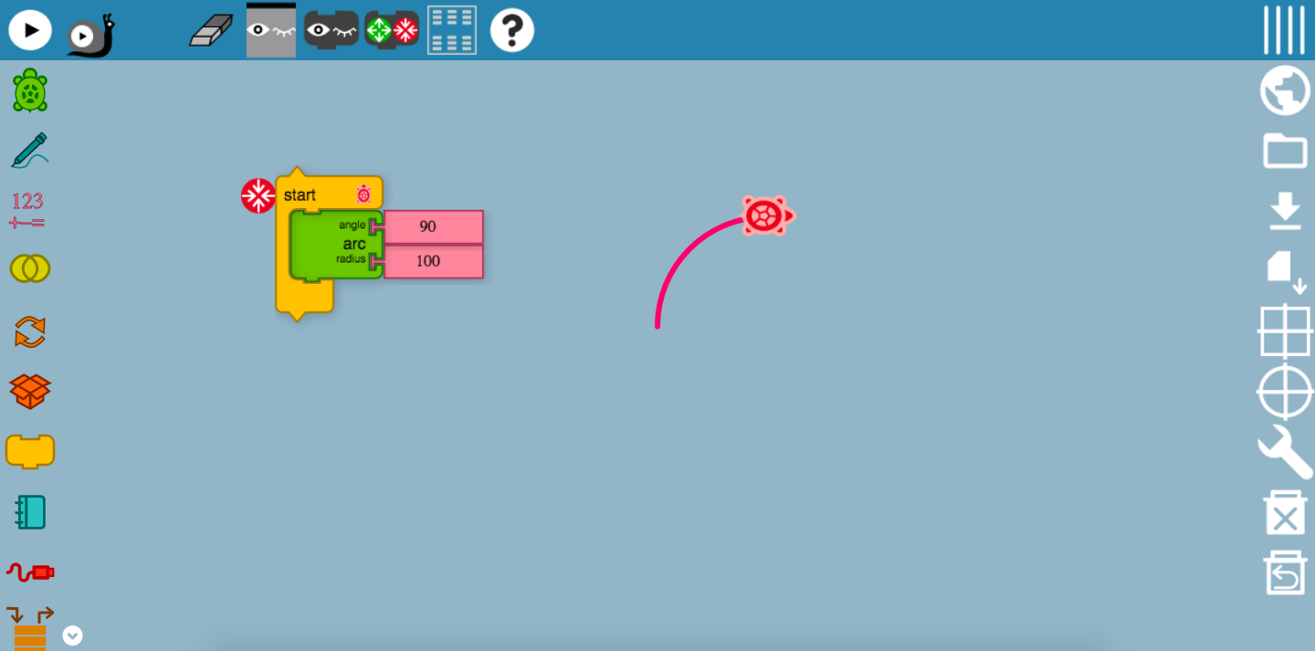

As it can be seen, this block controls the angle that the Turtle would be moving. Have you noticed the 90 turning point? This is a result of the angle of the block being set to 90. However, in this block, we do not expect a sharp 90 turn, unless we specify the arc radius to be 0 counts. In this case, we have set the arc radius to be 100 counts. The 100 counts specify the radius of this circle. By setting it to these values, we have created the arc of a quarter circle! 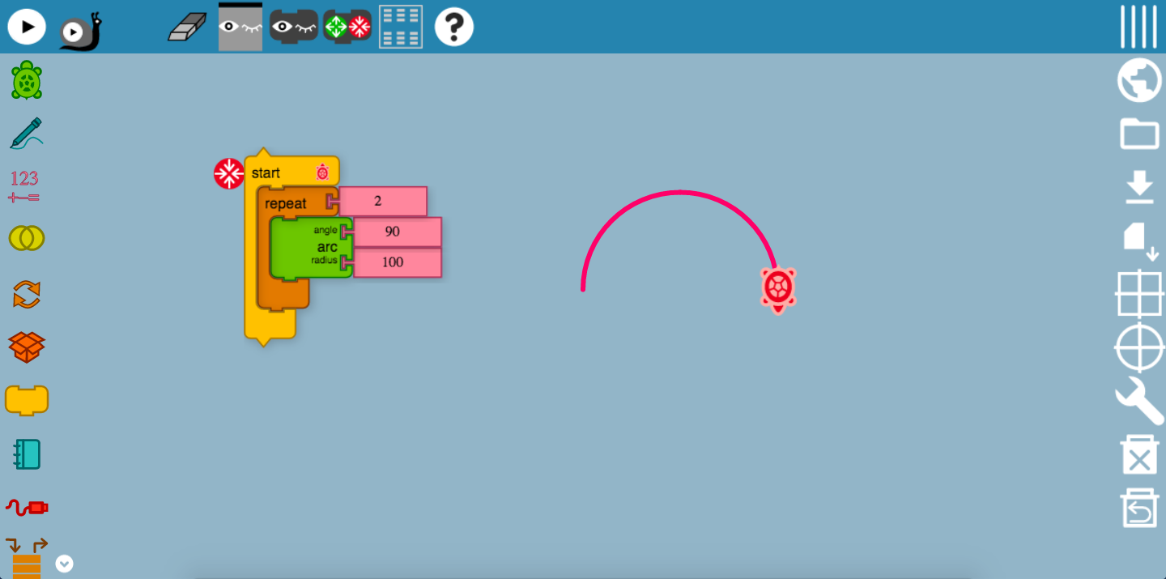

But, what about a semicircle? We could create another angle-arc-radius block with the same angle value, and combine them in a repeat block found in the flow palette? Why so? This will mean that the Turtle will be making another 90 turn and drawing the remaining radius of 100 units, setting the diameter of this semicircle to be 200 units.

Of course, we could change the angle and arc radius to different values to experiment with different designs! Moreover, try combining with different move blocks as well! But here’s a tip, a 360 angle count at any radius of your choice, would form a full circle! Alternatively, you could repeat the above codes 4 times.

## Bezier Block

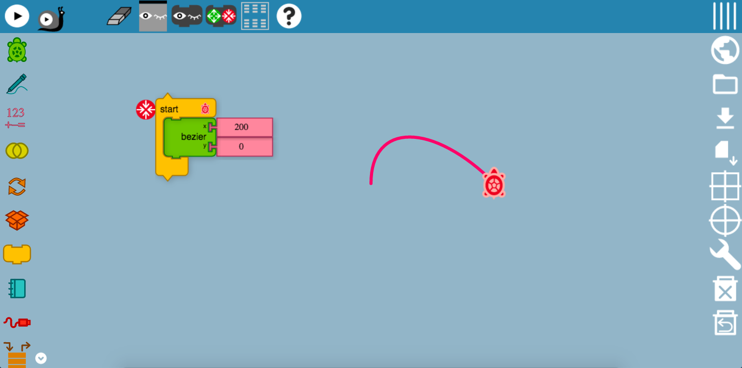

Well, the Bezier block may be slightly confusing. What is a Bezier? A Bézier curve is a parametric curve frequently used in computer graphics and related fields. Generalizations of Bézier curves to higher dimensions are called Bézier surfaces, of which the Bézier triangle is a special case. It looks something like this.

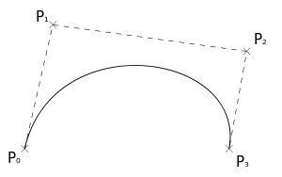

A Bezier block causes the Turtle to move in a very sharp angle. A smaller value gives a steeper and smaller curve, while a larger value gives a wider curve. The x represents the horizontal direction that the Turtle would be moving, while the y represents the vertical direction. Setting a higher y direction tends to create wider and longer curves, and curves would not tend to be too narrow. Try it yourself!

## Set Heading Block

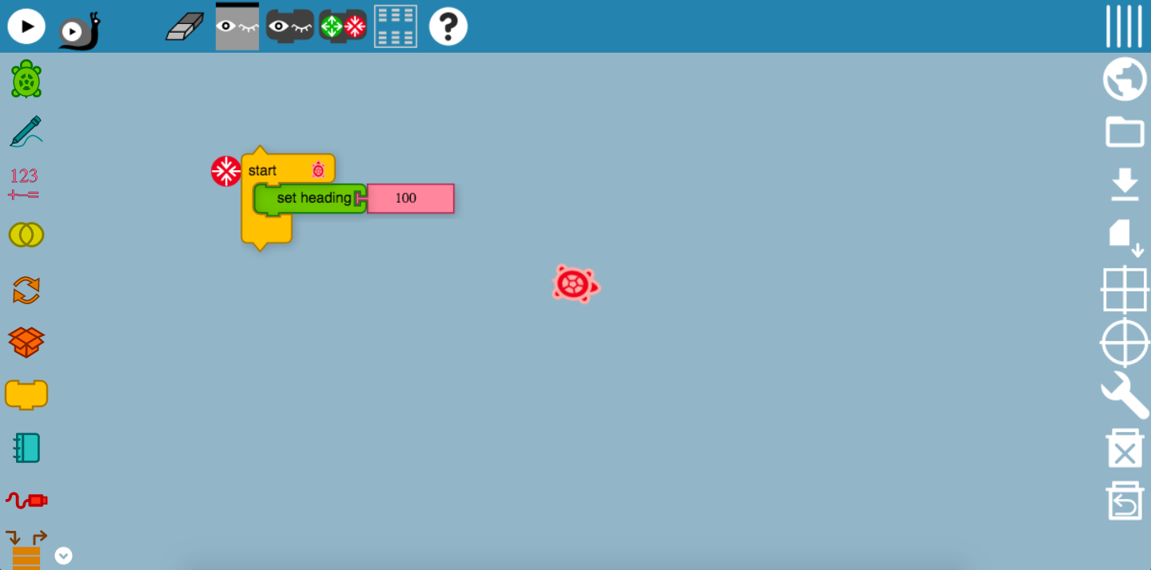

Well, the set-heading block really seems like a left and right movement block. As the name suggests, it specifies the direction that the Turtle would be heading to, based on the angle counts. In this case, assuming that the north direction is vertically upwards, the Turtle is in-between the east and south direction, but has not yet reached south-east. Always remember that the Turtle moves in a clockwise direction here!

## Set xy Block

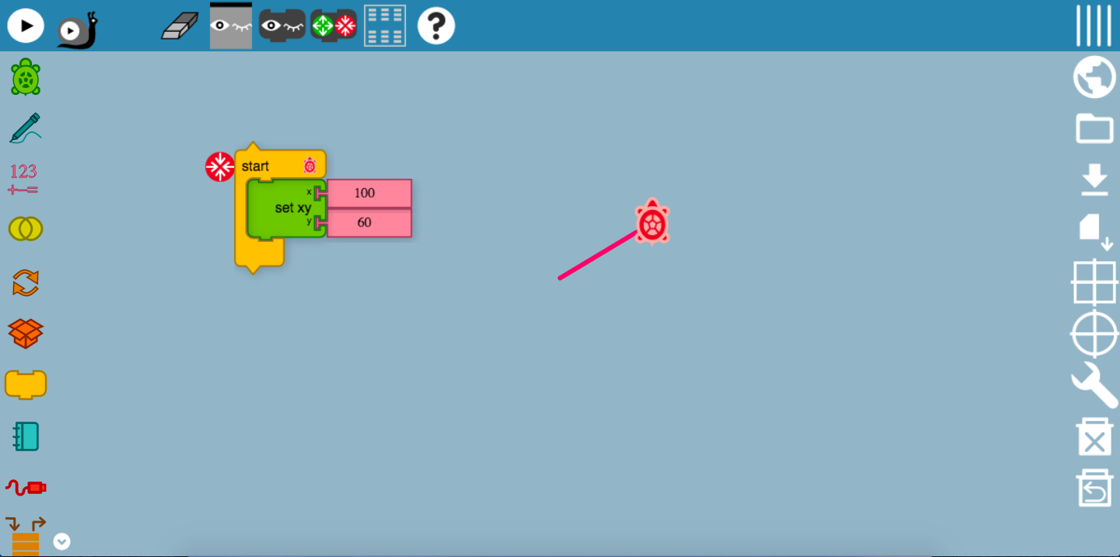

Doesn’t this xy block reminds you of the straight-line graph? Yes, it indeed is! Like the Bezier block, this block sets the x and y direction of that the Turtle would be moving to. In this case, the Turtle has moved 100 counts in the horizontal direction, which means that it is 100 horizontal counts away from the starting point. Applying the same concept, it is 60 counts vertically away from the starting point. However, have you noticed how the line is slanted and it is not exactly 60 vertical counts away from the starting point? The y point is in fact 60 vertical counts away from the end of the horizontal line, which forms this straight-line graph. It will be useful for you to form shapes and even applying the concept of graph. Perhaps, you may even want to use Turtle Blocks to visualize graphical equations!

# Media Palette

## Show Block

### Text Tool

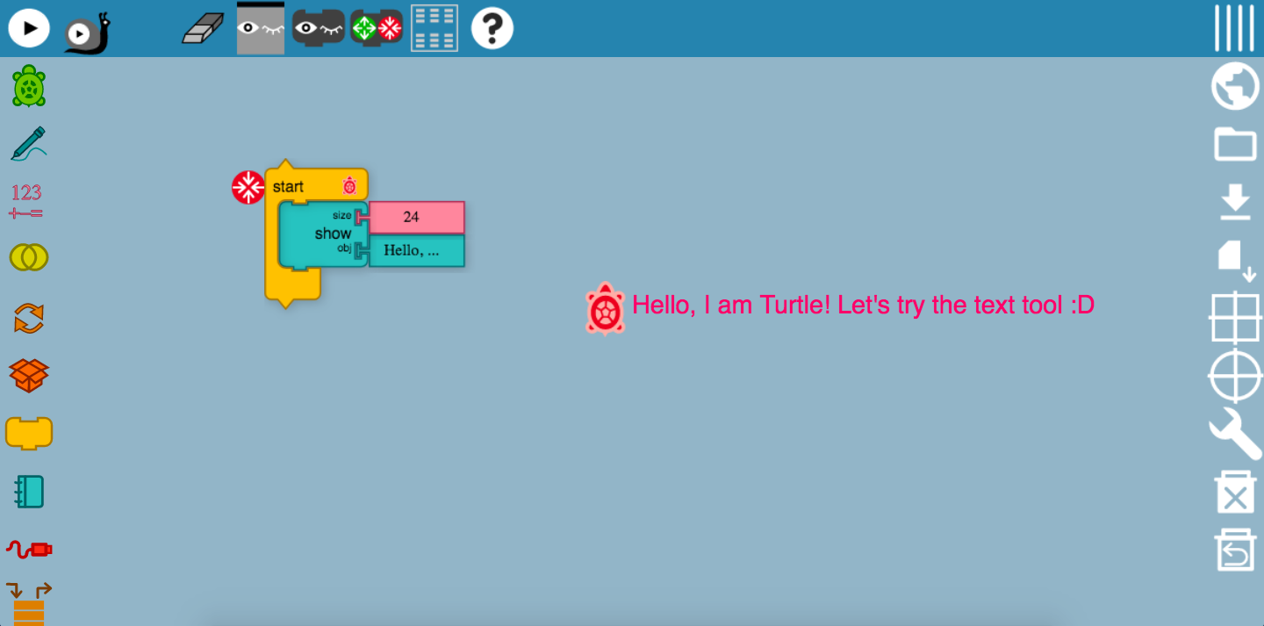

This is the show block! It displays the input that you have entered. For example, the size of the object here was specified to be 24, while the object, have been set to “Hello, I am Turtle! Let’s try the text tool!”. This explains what the Turtle is trying to show here. The object has been specified to be a text input. You could really try to experiment with font sizes and print out different texts on the screen!

### Video Tool

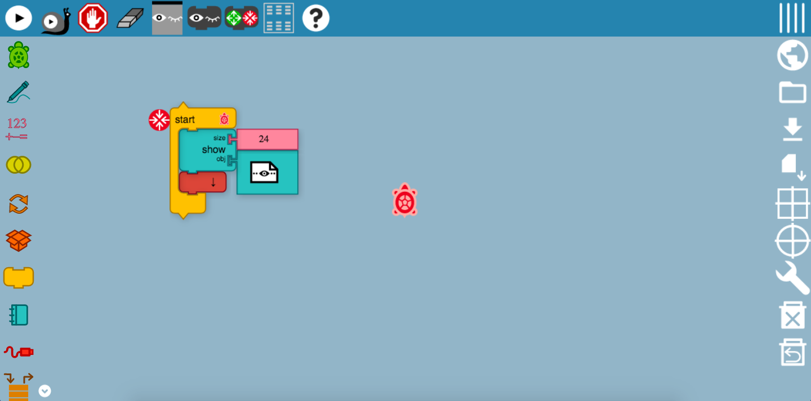

In the show block, one of the most amazing function is to display a live video camera on the canvas, which in this way, you can record anything that you want. To adjust the size of the video screen, you can also make edits to the size tool.

### Camera Tool

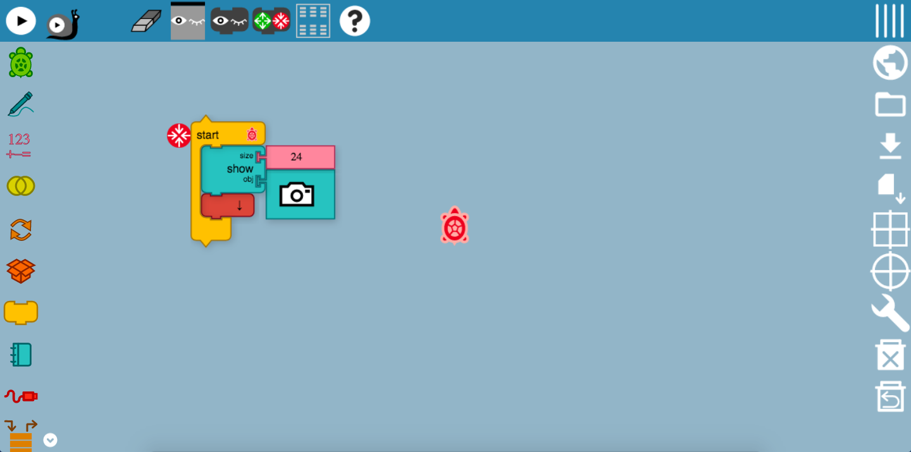

Like the video tool, the camera tool displays a camera screen on the canvas.

Try it now!

### Speak Tool

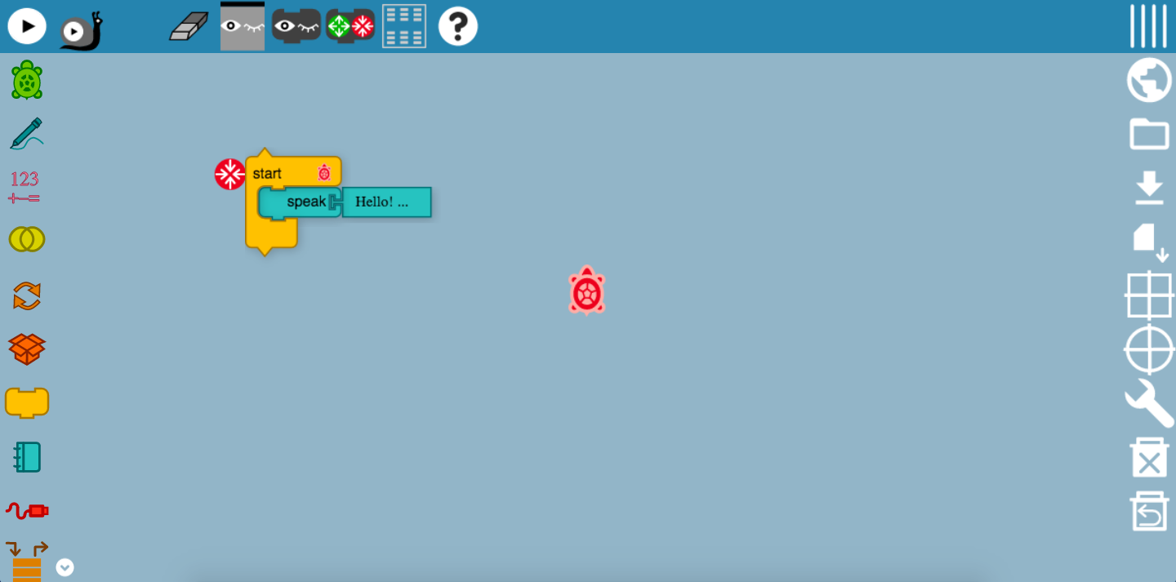

The speak tool is used to program the Turtle to produce sounds, of whatever that you have typed. For example, in this program, the input for the speak block is “Hello! I am Turtle.” So, turn up your volume and you can hear the sound output! Just imagine how this great function can help you to pronounce words, and even make your art even cooler as the Turtle speaks while creating shapes.

## Shell Block

### Image tool

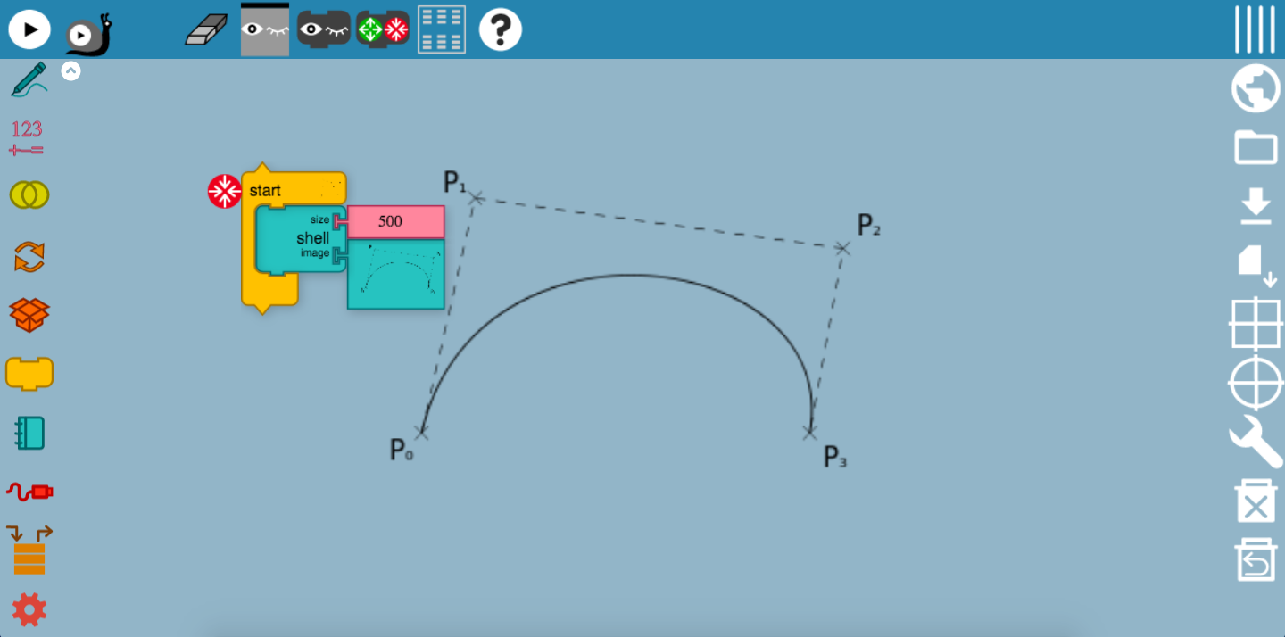

The image tool is handy for displaying different kinds of images on the canvas. You could even use the image tool to display a little map and create a program for the Turtle to draw it out!

## Turtle Shell

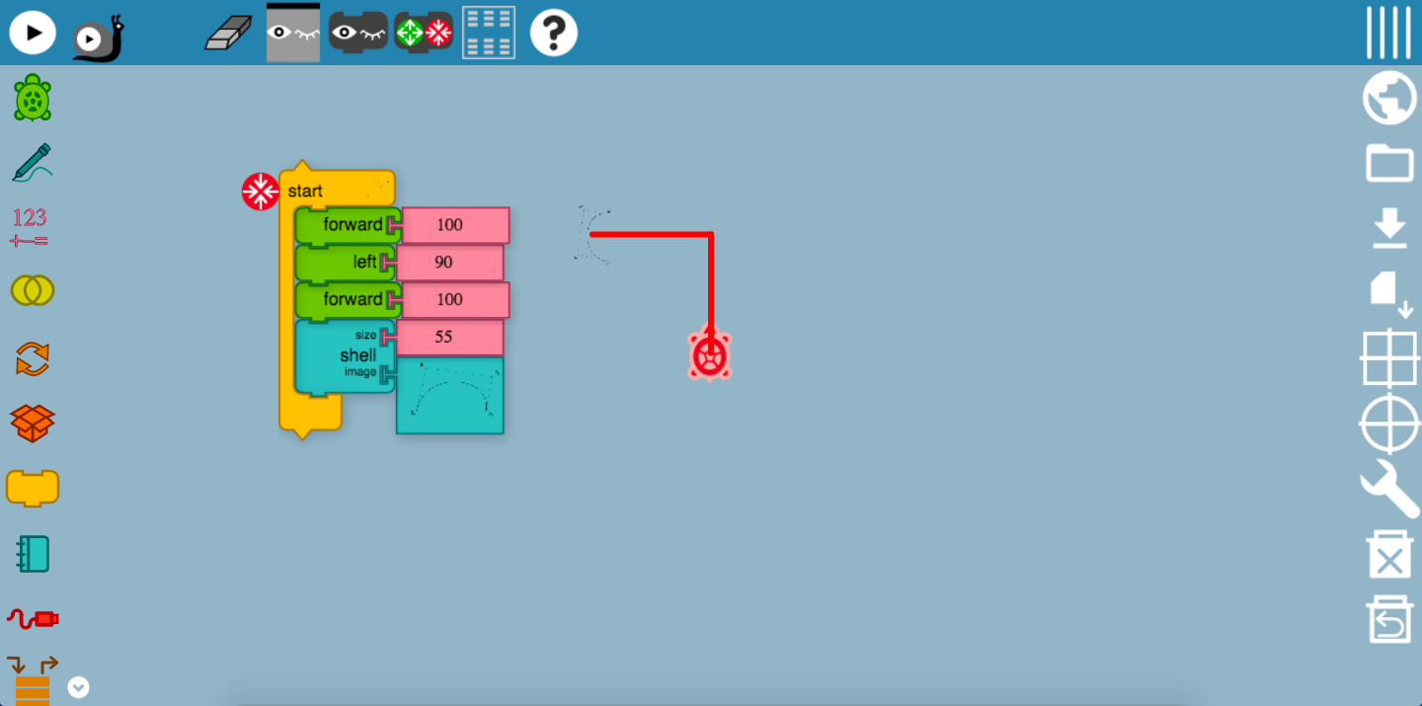

Perhaps you may be thinking, why am I using a Turtle to draw? Well, did you know that you could change the image of the Turtle? We call this, changing the image of the Turtle shell. Firstly, the Turtle has been programmed to more in a certain direction. This is to allow you to better visualize the shell image of the Turtle. Here, the Turtle’s shell was replaced with a Bezier!

# Sensors

## Loudness Block

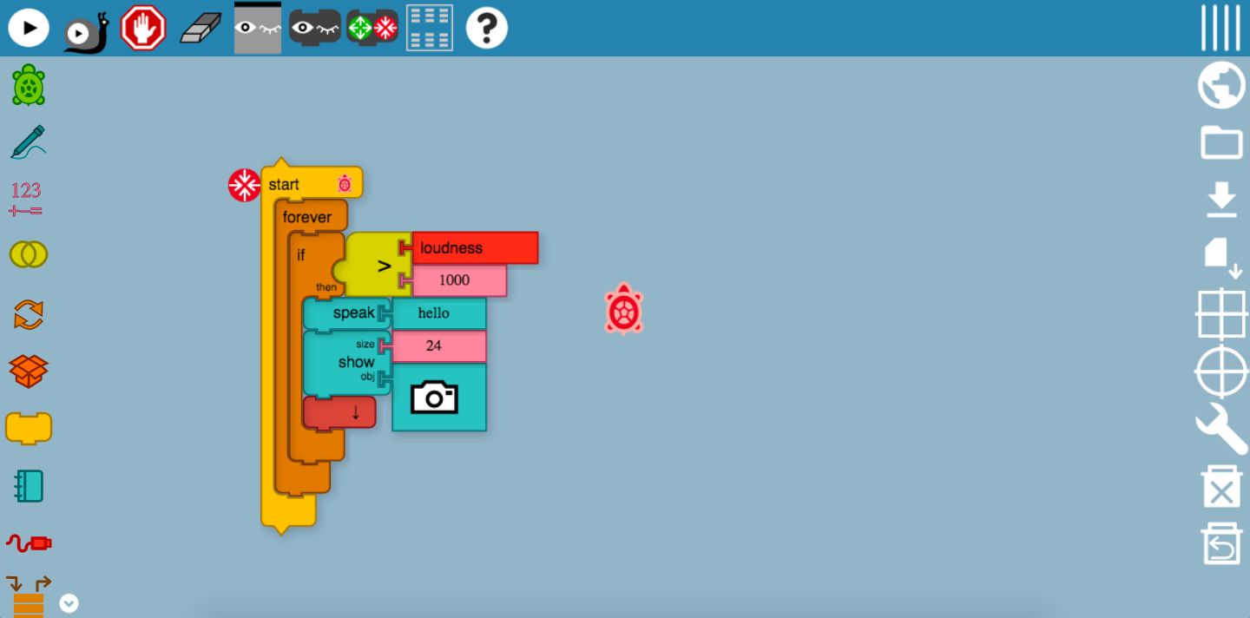

The loudness block is now working again, thanks to the constant updates and maintenance from the developers behind-the-scene. This program may seem slightly complicated, but don’t worry! The whole program was enclosed within a forever block, which means that this program would continue running on forever and ever, with no breaks and interruptions. Next, the if-then block would carry out the action. Firstly, if the Turtle sensed a loudness value of 1000 counts from the surroundings, it will say, “Hello”, and even take a snapshot of the surroundings!

## Mouse Blocks

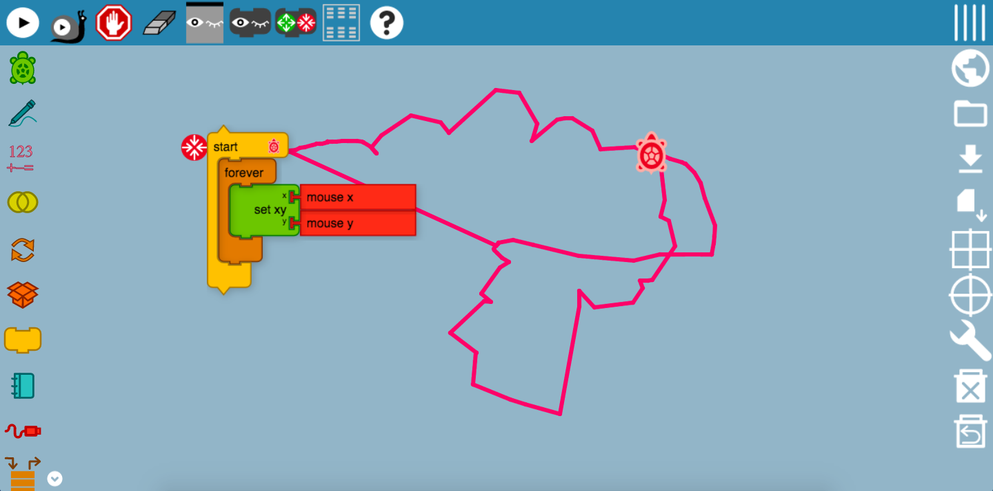

This mouse block is really nice to draw out different images. You can use a mouse-pad or even a mouse! Again, this program has been set to run forever without any interruptions, so one could continue drawing on and on unless the user stops the program. So, remember the set xy block? This block sets the x and y coordinates of the mouse and the Turtle will draw in the direction of wherever the mouse direction goes.

## Keyboard Block

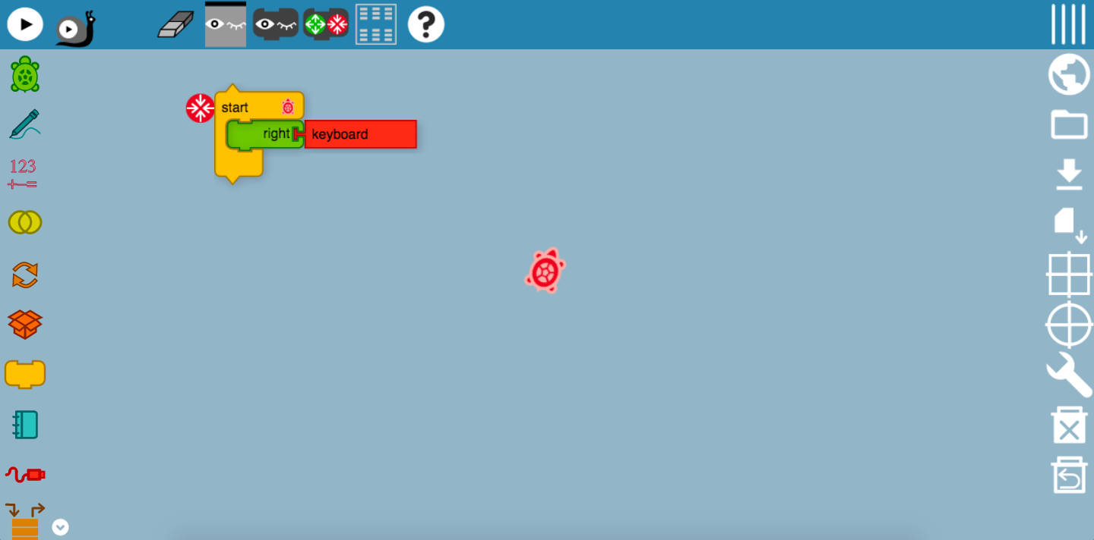

This is an amazing example of the sensor tool – the keyboard block! Just as how you would have used to control the Turtle by setting values, this will move the Turtle using the enter-key on the keyboard! In the image above, the Turtle is moving in a clockwise direction every time the enter-key is pressed.

## Time Block

## 

In the previous mouse blocks write-up, the color of the drawings remain the same throughout, and this makes it really hard to beautify your drawing. Here, a time block was inserted as an addition to the mouse blocks, so that the color of the pen tool would change after a set period of time, giving your drawings the extra touch of creativity.

# Extras Palette

## Save SVG Tool

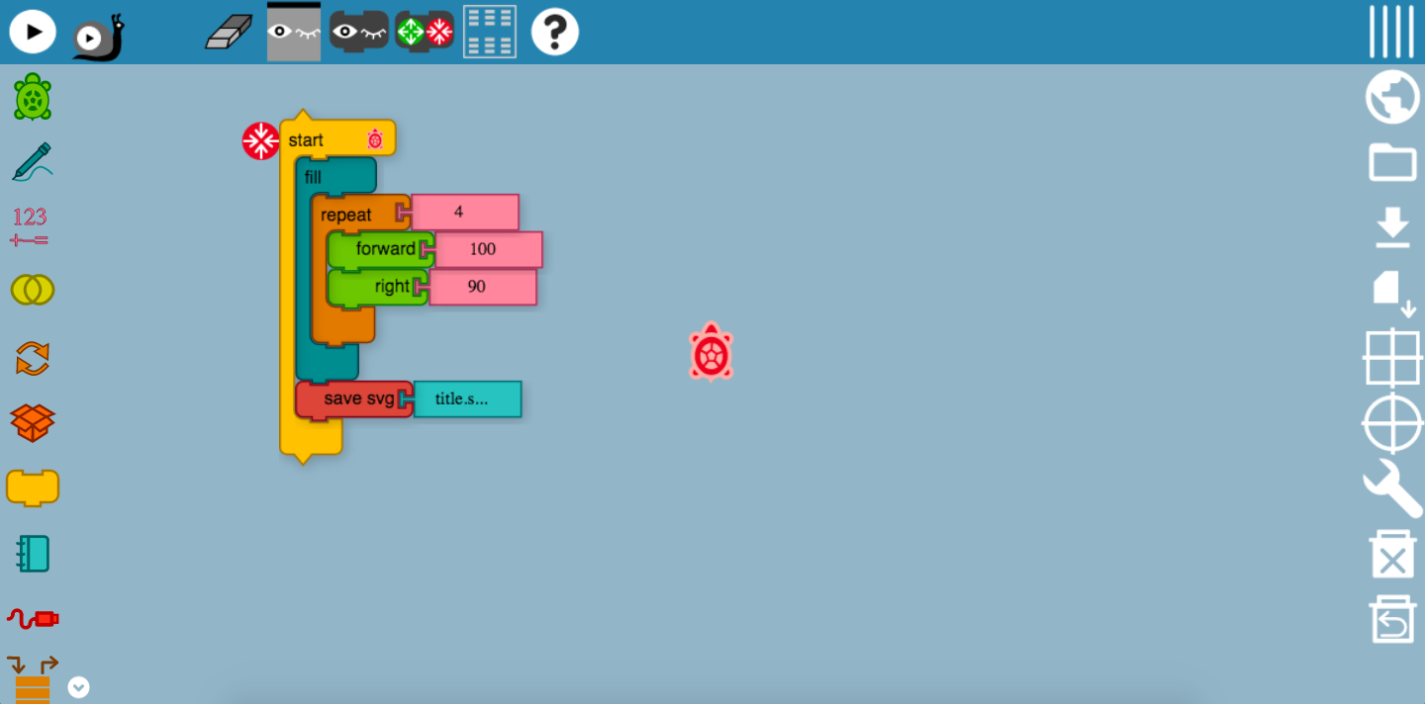

As it can be seen from the image above, I have created a colored square using the fill and movement tools. After which, the svg tool would be able to save the output of this program, which is the colored square into my files. It is useful in showing the output of the program without the palette and blocks.